Urban Drawdown Initiative
DECISION SUPPORT TOOL TRAINING GUIDE
Table of contents
Getting there 2
Accessing the site 2
Navigating the map 2
Zoom & pan 2
Change the map background 2
Interacting with the map 3
Selecting features 3
Interacting with the data 3
Set City of Interest 3
Carbon Calculator 3
Layers 5
Overlay data 5
Analysis results 5
Layers menu (transparency, layer swipe, metadata) 5
Query Data 6
Query by value 6
Query by location 7
10-Minute Walk Assessment Tool 7
Additional tools 8
Draw 8
Google Street View 8
Print (a custom map) 8
Get help 9

Getting there

Accessing the site
- Use the following link to connect to the Urban Drawdown Initiative landing page:
  - https://web.tplgis.org/udi/

- Click on the “Decision Support Tool” icon at the top of the landing page to access the mapping portal.

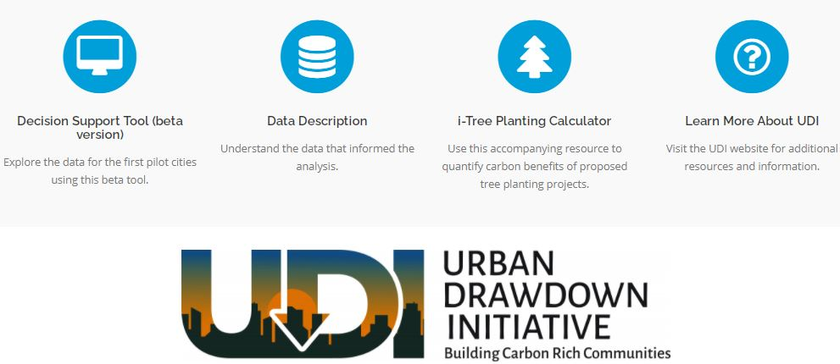

Navigating the map

Zoom & pan
- On the left-hand side of the map, click the ( + ) sign to zoom in and the ( - ) to zoom out.
- To zoom in to a particular area, hold down shift, click your mouse on one corner of the desired extent, and drag your mouse to the opposite corner of the desired extent.
- Click and drag your mouse to the right or left to pan around the map (adjusting your view).
Note: As you change the viewer extent the map detail changes. As you zoom in the map becomes more detailed.
- Click the button to return to the extent of the study area.

Change the map background
- Click the tab to the right of the map. Then click the checkbox next to the basemap you desire.

Interacting with the map

Selecting features
Most of the overlay layers included in the tool have attribute information that you can access through the map.
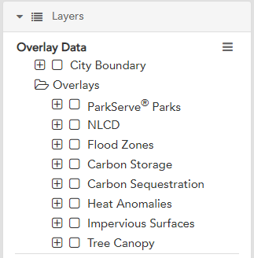
      - Turn on any layer(s) in the Overlay Data section.
      - Click on the map.
      - An information box will appear that describes the feature(s) that you clicked.
      - Note: If multiple layers are turned on, the one that is highest in the table of contents will be identified first.
      - If there is a in the info box title you have identified multiple features. Click to view information on the other selected features.

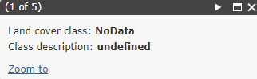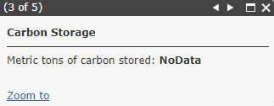

Interacting with the data
On the left side panel there are a number of “functions” available. Click on the to open a tool if it is closed. This section will provide guidance for using each of the tools listed on the left hand side of the screen.

Set City of Interest
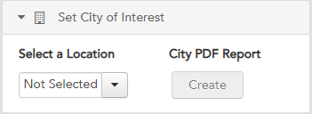
To see data for one of the seven participant cities, set the City of Interest using the dropdown menu. From there, you can create and download a PDF Report for that specific City.

Carbon Calculator
To use the Carbon Calulator, first select the desired land use from the dropdown menu.

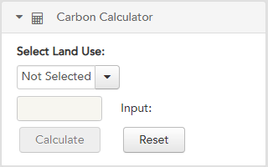

Then select the desired treatment from the dropdown menu.

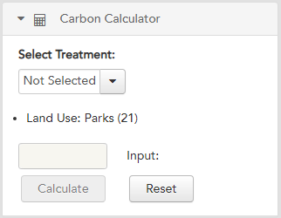

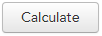
Finally, insert the desired number of acres to analyze and hit the button. Your result will appear in bold. Results = net emissions. Therefore a negative number shows a net reduction in emissions; a positive number shows a net increase of emissions based on the management practice and acreage selected.

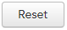
Hit the button to reset the calculator.
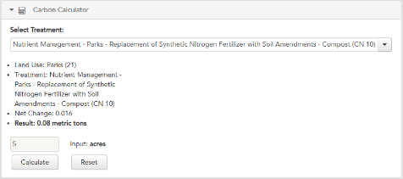

Layers
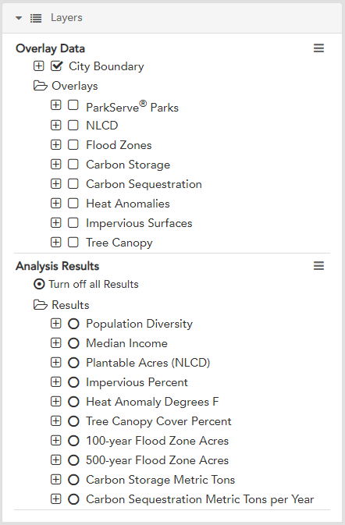
If you click on you will see all the layers in the viewer, including all of the Overlay Data and Analysis Results collected for the tool. For both overlays and analysis, the layers are categorized:
- Each symbol indicates that there are multiple layers grouped under that heading. Click the to expand and see what layers there are.
- Click to show the symbology for an individual layer.

Overlay data
Overlay data provides important context for the region or study area across climate objectives. This data includes the base information used for analysis.
- Multiple overlay layers can be turned on at once.

Analysis results
Analysis results provides model data to identify priorities across all Climate-Smart Cities objectives. All analysis layers are symbolized in five categories from light to dark to signify very low, low, moderate, high, and very high priorities.
- Only one analysis layer can be turned on at once.
- At the top of the analysis layers list there is an option to turn off all results layers. If at any point you would like to remove all the results, click this.

Layers menu (transparency, layer swipe, metadata)
The layers menu provides tools that adjust the view of overlay data and analysis results you see on the map as well as metadata that provides information about all of the data included in the tool. There is an independent layers menu for overlay data and analysis results. Click on the to the right of the Overlay Data or Analysis Results headings to access the following tools:
- On/off functions: Turn on all the overlay sublayers, turn them all off or zoom to the layers.
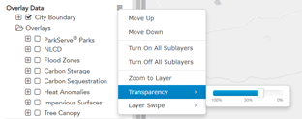
- Transparency slider: Changes the transparency of the overlay data so that you can see mapped features underneath the overlay data. Click the rectangular tab on the slider and hold the mouse button down to drag it to the left or right.
  - Experiment with different transparency levels. Notice that the transparency level of all overlay data changes as you change the transparency level.
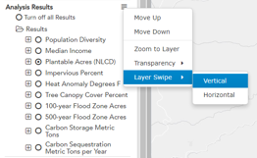
- Layer Swipe: Provides the capability to use a slider to see what the map looks like with a layer on or off.
  - If you hover your mouse over the Layer Swipe you can choose either vertical or horizontal. A bar will appear in the viewer and you can slide it up/down or right/left depending on if you selected vertical or horizontal. Sliding this bar will show you what the map looks like with or without the data.
  - To exit Layer swipe mode, click on the 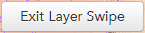 box at the top of the map.

Query Data
The query data function allows users to search for the characteristics required by a specific project, interest, or proposal. All modeled climate criteria and important physical characteristics of a site are tagged to blockgroups and available for export. Users can either query by value (information tagged to the blockgroup) or by location.

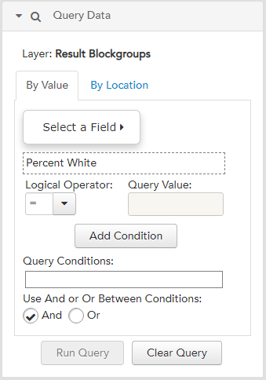
Query by value
- Select the field you would like to query on from the “Select A Field” menu.
- Select the Logical Operator, enter Query Value and press “Add Condition.” The condition will appear. You can remove it at any point by clicking .
- After you have added all the desired queries click .
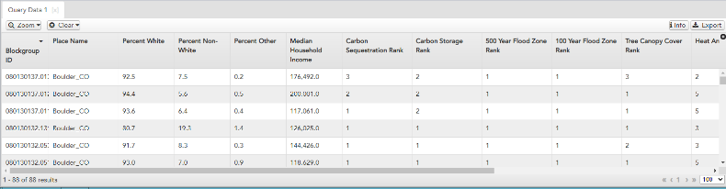
- A table will open at the bottom of the viewer showing you the data that fits your query.

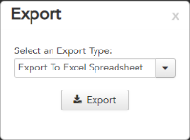
- Note: You can clear a query at any point by clicking the tab.
      - You can export this data as either an excel or csv file report.
      - To further refine a query, you can add another condition. Perform the same steps as above for any additional conditions you would like to include. Note: Make sure and click “Add Condition” after you have set up your condition. Once this is done a second condition with appear in your query conditions.

Query by location
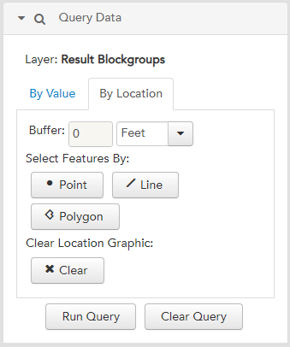
      - You can choose point, line, or polygon options to select features and define the buffer of that geometry. Once you have chosen both the buffer and the geometry, you will draw on the map defining the point, line, or area that you would like to query.
      - Select .
      - From here, this tool functions the same as Query by Value. A table will open at the bottom of the viewer showing you the blockgroupss that fit your query. You can export this data as either an excel or csv file report.

10-Minute Walk Assessment Tool
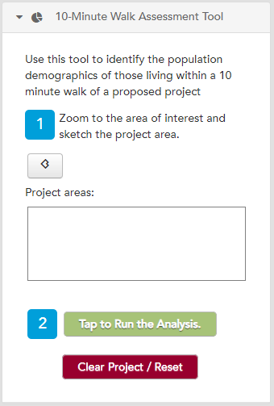
The 10-minute walk assessment tool allows you to generate a 10-minute walkshed for any project area and then summarizes basic demographic information, including population, age, race and household income, for that location. It is often used for grant reports to show who will be impacted by a proposed project.
Draw the project boundary by clicking the polygon button () then drawing a project boundary.
Click the 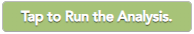button. Or click the button to clear your entries.

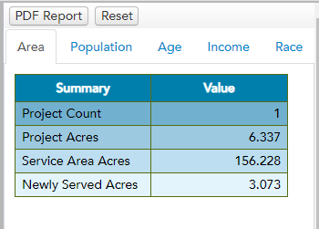
Once you run the analysis, demographic summaries of people impacted within a 10-minute walk of your proposed project will be generated in the right hand side of the tool. Press the PDF Report (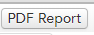) button to generate a pdf of the demographic summaries.

Additional tools

Draw
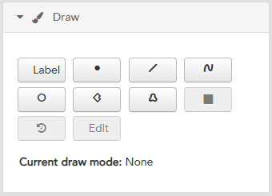
The draw tool allows you to add graphics to your map.
      - Click the Draw tab on the left panel to add graphics to your map.
      - To sketch a polygon on your map, click the button.
      - Begin sketching a shape on your map by clicking on your map. Double click to finish the sketch.
      - You can also add points, lines, circles, and freehand polygons to the map by using the other draw buttons.
      - If you want to change the graphics, use the button, and recreate the graphics using the methods described above. Note: This action will erase all your drawings.
      - To stop drawing click the button.

Google Street View
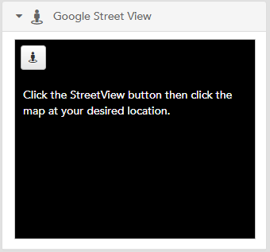
Users can see the street view image for anywhere on the map in two clicks.
      - Open the Google Street View tab.
      - Click 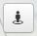, then click the area on the map you would like to see in Google Street View.
      - You can choose other locations to see in Google Street View by repeating the process above.

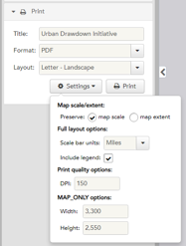
Print (a custom map)
Users can print custom maps with a legend and title of your choosing that includes analysis results and/or any overlay layers that match your interests or goals.
      - To print a custom map that reflects the data and zoom level that you have chosen above, click the Print tab on the left panel.
      - Enter a title for your map in the space provided.
      - Choose the format and layout you would like.
      - Click to make other adjustments to your printed map.
      - Click the button once you have completed the above steps.
      - Be patient while the mapping site generates a map for you. This process can take up to a minute.
      - In the PRINT tab a file will appear once the export is complete. Click on the link to open your map.
      - An 8.5 X 11 formatted map will be displayed that you can print or save to your computer hard drive to share with others.
      - Close the export window to return to the original map.

Get help
      - You can always click the button at the top right corner of your map for a copy of this user guide and tutorial.
Still need help? Send an email to gis.support@tpl.org

